

Practices for Secure Software Report

Table of Contents
Document Revision History 3
Client 3
Instructions 3
Developer 4
1. Algorithm Cipher 4
2. Certificate Generation 4
3. Deploy Cipher 4
4. Secure Communications 4
5. Secondary Testing 4
6. Functional Testing 4
7. Summary 4
8. Industry Standard Best Practices 4

Document Revision History

Version | Date | Author | Comments
1.1 | 20261018 | Codden, Isaiah

Client



Instructions

Submit this completed practices for secure software report. Replace the bracketed text with the relevant information. You must document your process for writing secure communications and refactoring code that complies with software security testing protocols.

- Respond to the steps outlined below and include your findings.
- Respond using your own words. You may also choose to include images or supporting materials. If you include them, make certain to insert them in all the relevant locations in the document.
- Refer to the Project Two Guidelines and Rubric for more detailed instructions about each section of the template.

Developer
Codden, Isaiah J.

Algorithm Cipher

For Artemis Financial, I believe that AES-256-GCM would the most prudent of the encryptions algorithm to implement due to its ability to protect sensitive financial information without compromising the application's performance. AES is a symmetric block cipher that utilizes a 256-bit encryption key and operates on 128-bit blocks through 14 rounds of cryptographic transformation. One of its primary advantages is authenticated encryption with associated data (AEAD), which provides confidentiality while allowing unauthorized modifications to be detected. However, I would also consider the importance of utilizing a cryptographically secure pseudorandom number generator (CSPRNG), such as Java's SecureRandom API, and maintaining unique initialization vectors (IVs) to mitigate potential vulnerabilities. Without proper key management, even a formidable encryption algorithm can become susceptible to security deficiencies (National Institute of Standards and Technology [NIST], 2023; Dworkin, 2007).

I would also recommend incorporating both symmetric and asymmetric cryptography, since each serves a different purpose within the application's security architecture. Symmetric encryption is more efficient for protecting larger amounts of data, while asymmetric encryption supports digital signatures and secure key establishment. For this project, I utilized a 3072-bit RSA key pair, an X.509 certificate, and SHA-256 through Java's MessageDigest API to support secure communications and checksum verification. Historically, encryption standards have evolved from algorithms such as DES, which became vulnerable due to its 56-bit effective key length, to AES, which was standardized in 2001 and updated in 2023. I believe implementing AES-256-GCM would establish a more resilient framework, but maintaining its effectiveness would require a methodical approach, continuous diligence, and accountability when managing cryptographic keys and potential security risks (NIST, 2023).

Certificate Generation
Insert a screenshot below of the CER file.

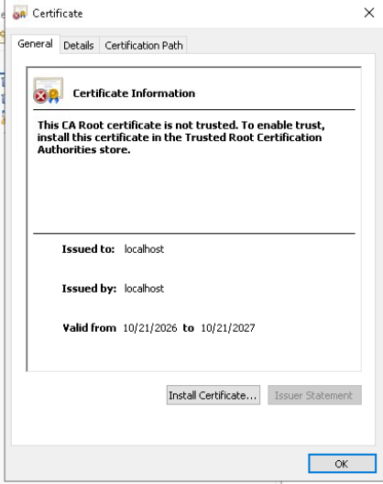
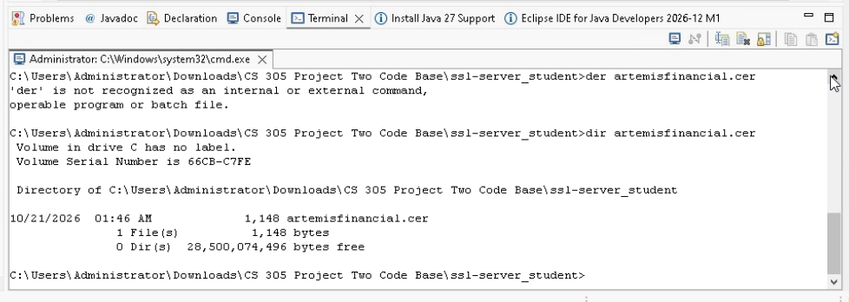

I generated a self-signed certificate for Artemis Financial using Java Keytool with a 3072-bit RSA key pair and the SHA256withRSA signature algorithm. To reinforce the application's security, I configured the certificate for localhost and exported it as artemisfinancial.cer to validate that the certificate was successfully generated. This process establishes a foundation for secure communications while demonstrating a proactive approach to protecting the application's integrity. The certificate is valid from October 21, 2026, through October 21, 2027, and will support HTTPS testing within the local environment.

Deploy Cipher
Insert a screenshot below of the checksum verification.

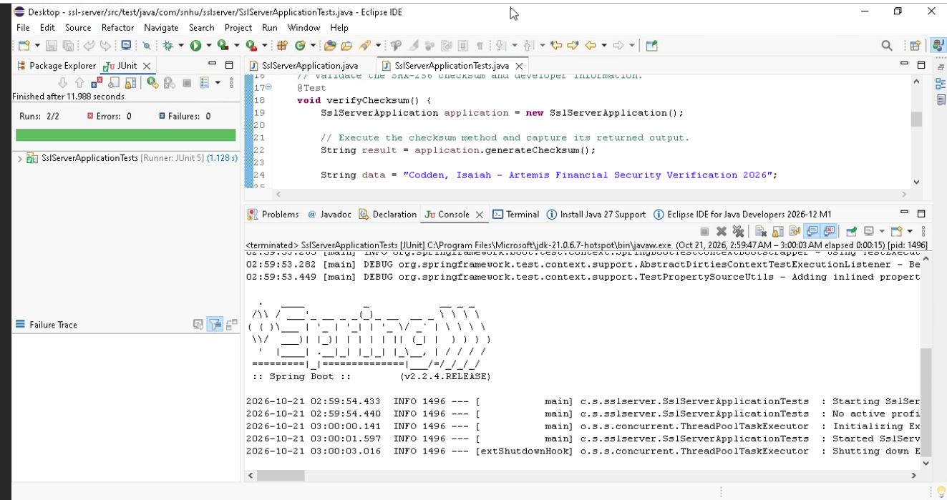

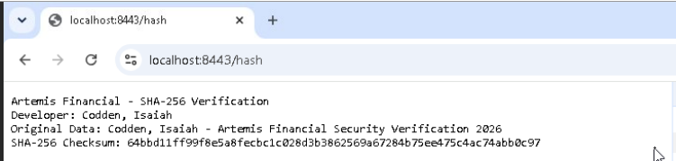
I implemented the SHA-256 cryptographic hash algorithm within Artemis Financial's application to reinforce data integrity and provide a reliable checksum verification process. The application generates a unique 256-bit hash from my designated data string, allowing us to validate that the information remains consistent and has not been altered. I also conducted JUnit testing, which successfully passed both tests with zero errors or failures, demonstrating the functionality and reliability of the implementation.

Secure Communications
Insert a screenshot below of the web browser that shows a secure webpage.

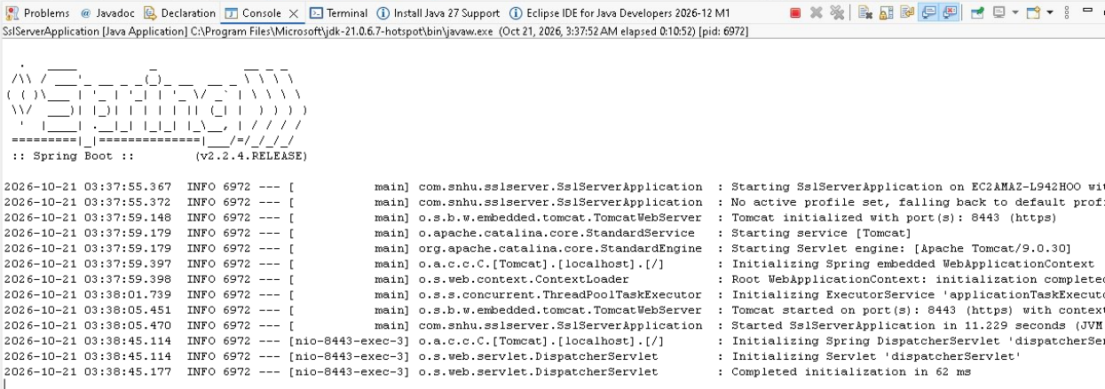
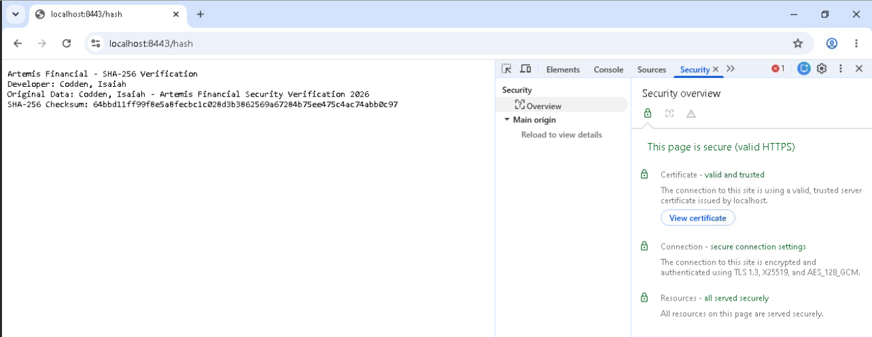

I refactored Artemis Financial's application to establish secure HTTPS communications on port 8443 using a self-signed SSL/TLS certificate. After configuring the certificate within the local testing environment, Chrome's security inspection confirmed a valid and trusted HTTPS connection utilizing TLS 1.3, X25519 key exchange, and AES-128-GCM encryption. These security measures reinforce the confidentiality and integrity of transmitted information while mitigating potential interception risks. The implementation successfully demonstrated secure communications between the application and browser.

Secondary Testing
Insert screenshots below of the refactored code executed without errors and the dependency-check report.
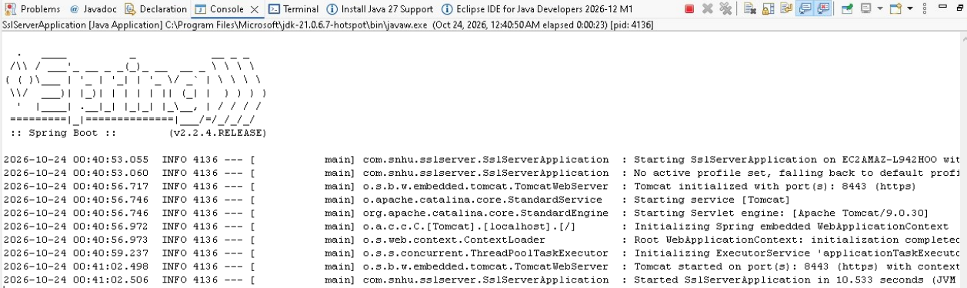
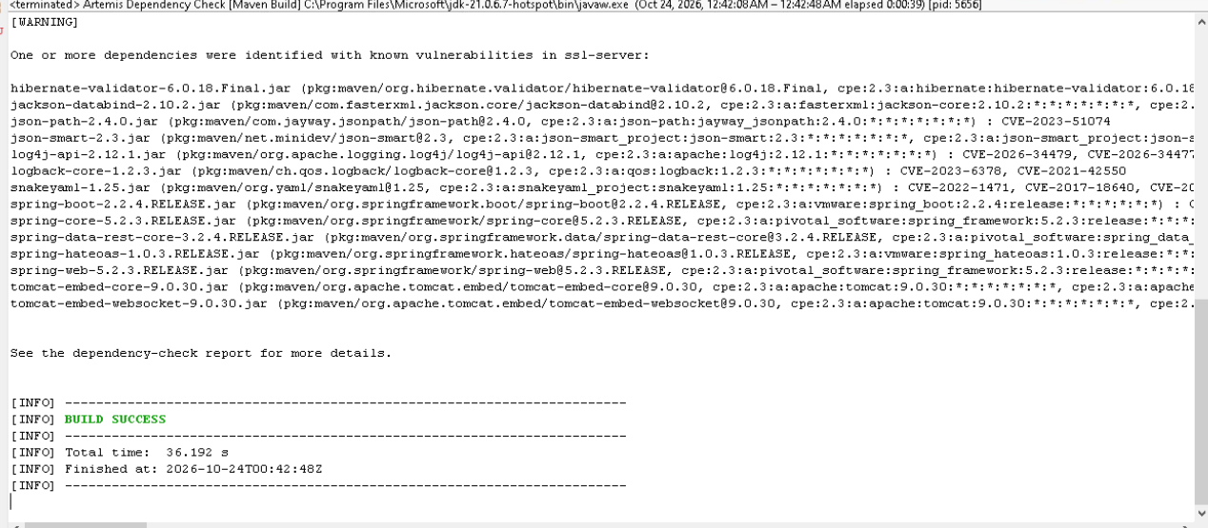
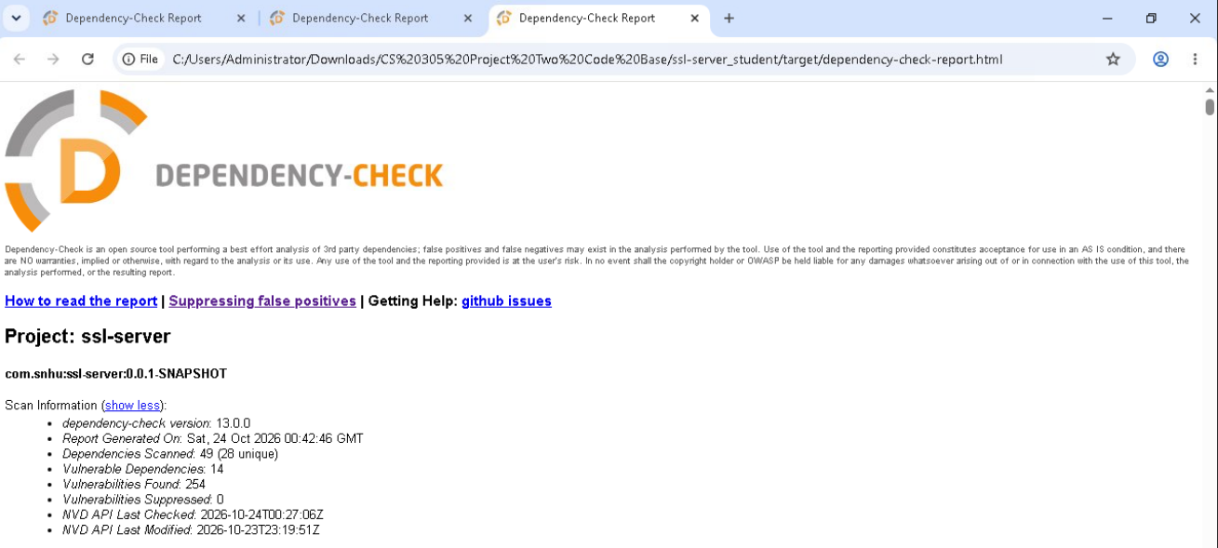
I conducted secondary security testing on Artemis Financial's refactored application using OWASP Dependency-Check 13.0.0 to identify potential vulnerabilities within the application's existing dependencies. The assessment successfully scanned 49 dependencies and identified 14 vulnerable components associated with 254 reported findings. Several of these vulnerabilities were associated with the older Spring Framework and Apache Tomcat libraries, demonstrating the importance of maintaining current software components. Although the application executed successfully and the dependency scan completed without build errors, these findings require further evaluation and remediation. This process helped validate the application's functionality while reinforcing a proactive approach to vulnerability mitigation and maintaining the integrity of the software.

Functional Testing
Insert a screenshot below of the refactored code executed without errors.

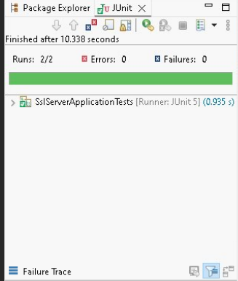
I conducted functional testing on Artemis Financial's refactored application by manually reviewing the source code for syntactical, logical, and security vulnerabilities. During this assessment, I verified the SHA-256 checksum implementation, confirmed the integrity of the hexadecimal output, and evaluated the application's exception handling. I also executed two JUnit tests to validate the application's functionality, with both tests passing successfully without errors or failures. This testing process reinforced the reliability of the refactored code while demonstrating a proactive approach to identifying potential security deficiencies. The remaining vulnerabilities identified within the existing third-party dependencies will require further remediation.

Summary

Throughout this project, I refactored Artemis Financial's application to reinforce its security architecture while maintaining the integrity and functionality of its existing software. Following the vulnerability assessment process, I took a methodical approach to identifying potential security deficiencies, with my primary focus on cryptography, secure communications, and code quality. I implemented the SHA-256 cryptographic hashing algorithm through Java's MessageDigest API to establish a reliable checksum verification process, utilizing UTF-8 encoding to maintain consistency throughout the data transformation. Additionally, I generated a self-signed X.509 certificate using Java Keytool with a 3072-bit RSA key pair and configured HTTPS communications through TLS 1.3 on port 8443. These modifications were imperative in establishing a more resilient application while mitigating potential risks associated with data interception and unauthorized modification.

To establish a more comprehensive security framework, I incorporated multiple layers of protection rather than relying on a singular security mechanism. This included certificate-based authentication within the local testing environment, cryptographic integrity verification, and exception handling to prevent unnecessary exposure of internal application information. I also conducted functional testing using JUnit assertions to verify the accuracy of the checksum and confirm that the application executed without errors. Furthermore, I performed secondary security testing using OWASP Dependency-Check to scrutinize the application's third-party dependencies for known Common Vulnerabilities and Exposures (CVEs). Although the assessment completed successfully, it identified 14 vulnerable dependencies associated with 254 reported findings, demonstrating that additional remediation is necessary. Overall, this process reinforced the importance of diligence, accountability, and continuous security evaluation when developing software that manages sensitive financial information.

Industry Standard Best Practices

Throughout the refactoring process, I applied industry-standard secure coding practices to reinforce Artemis Financial's security architecture and mitigate potential vulnerabilities within the application. One of my primary considerations was establishing a methodical approach to protecting sensitive financial information through cryptographic integrity verification and secure communication protocols. By implementing the SHA-256 hashing algorithm through Java's MessageDigest API, I established a consistent method for detecting unauthorized data modifications when compared against a trusted checksum. Additionally, I configured TLS 1.3 encryption using a self-signed X.509 certificate and a 3072-bit RSA key pair to strengthen confidentiality during data transmission. These measures were imperative in establishing a more resilient application while reducing unnecessary exposure to potential security threats.

Another critical component was maintaining diligence throughout the software development lifecycle (SDLC) by incorporating static dependency analysis, controlled exception handling, and automated regression testing. Using OWASP Dependency-Check, I scrutinized the application's third-party dependencies for known Common Vulnerabilities and Exposures (CVEs), identifying 14 vulnerable dependencies associated with 254 reported findings. Although the vulnerability assessment completed successfully, these findings demonstrate that additional remediation is necessary to address outdated software components. By maintaining accountability throughout the security testing process and prioritizing necessary corrections, Artemis Financial can establish a more comprehensive and sustainable approach to protecting its applications against known security vulnerabilities.

